Pilgrimage with the Buddha Metta Society in Thailand (Isaan region) 2-17 January 2015
My dream as a teenager was to join Medicines San Frontier as part of its team of Doctors without Borders. Instead, 19 years on, I find myself as part of a multi-cultural team demonstrating Dhamma without Borders....
Our group of 12 pilgrims led by Ajahn Sudhiro and accompanied by Tan B (Brendan) and Tan C (Christian) consisted of people from various parts of the world – 3 Americans, 2 Malaysians currently residing in the UK, 5 British, 1 Thai currently residing in New Zealand and 1 Thai from near Bangkok. Some of them have repeatedly made this trip in the preceeding years, whilst it was a new experience for the rest of us.
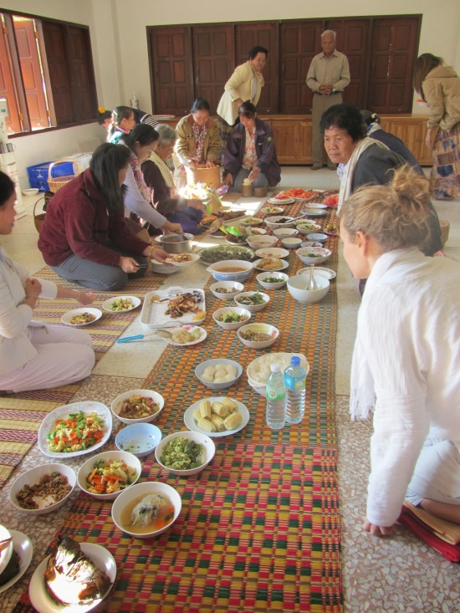
The 2 weeks of travelling from monastery to monastery was unlike the other sightseeing holidays I have been on in the past. Our journey begun in Khon Kaen at Wat Pah Kanjanapisek with Ajahn Sudhiro’s birthday and the rice harvest celebrations. Prior to playing with the local children whilst feasting on the village offerings, we were reminded to generate gratitude to our parents for our gift of life as Ajahn Sudhiro led a ceremony in memory of his parents. The reality of ageing, sickness and imminent death was brought to mind when we visited Luang Por Mahaso at Wat Pah Kam Can Nua. Christian’s head shaving in preparation for his ordination unfolded the following day. It’s only Day 4, and already we have stumbled across reminders of the Buddha’s 4 encounters when he left the palace gates over 2558 years ago.

Each morning started with following the barefooted monks on their almsround (pindapat). Local villagers would line the streets with food offerings to await our arrival. With palms held together in anjali, they greeted us with big smiles and the words “Savadeeka” (hello), “Savadee Pi Mai Ka” (Happy New Year), “Now mai” (Are you cold?) and “Sabbai di” (How are you?). The monks’ visit each morning provides them with the opportunity to give dana and practice generosity. Unlike in the West, I found that the Thais were very open handed in giving, and equally open to the idea of ‘allowing’ others to practice generosity by gratefully receiving anything that is offered. It was a beautiful practice to watch and embrace. The practice fitted well with Ajahn Sudhiro's mother's advice to him as a young child - "Don't eat without offering dana, don't leave the house without taking the 5 precepts, don't sleep without meditating".

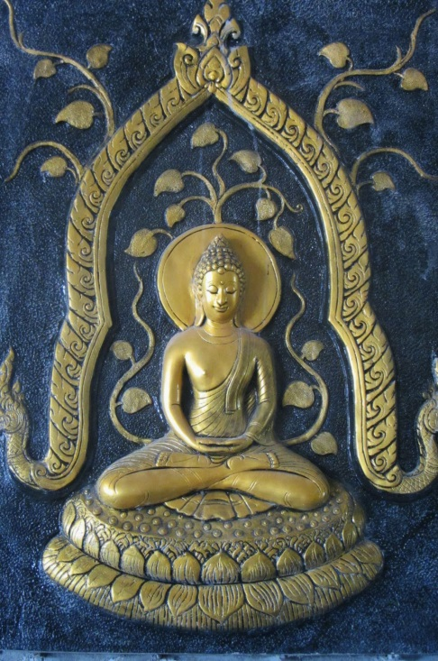
The ensuing days unfolded with us hopping from monastery to monastery, transferring metta (loving kindness) to its resident stray dogs and listening to live dhamma talks from the respective abbots. Some members of the team reminisced at the construction site of the reclining Buddha at Wat Pah Kittiyanusorn where they had helped to lay concrete in previous years. At Wat Sri Pu Wieng, we observed the recitation of the 277 rules of the patimokkha and the ordination of Tan C as Garudhammo (meaning 'steady in the dhamma' in Pali). Despite the distracting psychedelic lights emiting from a Buddha rupa at Wat Thum Pha Kurng and its huge ornate display of nagas, we were entranced by its abbot's dhamma talk urging us not to run away from our fears and to frequently recollect the teachings of the Four Noble Truths. Luang Poo Thongma repeatedly blessed us at Wat Tam Kaeng (deer cave) whilst encouraging us to let go of everything (ie thoughts and attachments) at night as we lay in bed because we never know when we will draw our last breath.

It's clear to see why Wat Tham Pah Wieng stands out for me as a memorable experience in this trip. It was here that Peter, Joan and I spent the night in a cave with countless bats. We abandoned our initial plan to return to the sala for evening chanting as it was too hazardous to manoeuvre our way up the dilapidated trail to the cave in moonlight. Therefore, we opted instead to do a short evening chanting and meditation session of our own. The cave filled with our faltering chants of the Ten Perfections, reflections of universal well-being, the Buddha's word on loving kindness and reflections on sharing blessings before subsequently falling to silence as we sat in meditation in the darkness. I had a very disturbing sleep that night - one may blame it on the unfamiliar surroundings, the visions I had of unfamiliar faces, the weird but short dreams that filled my sleep or the loud bang followed by the silhoutte of a man in glowing white light making its way to the mouth of the cave. I thought the latter was Peter making his way to the 'toilet' in the middle of the night, but he later denied this having been fast asleep through the night. It was only revealed by the abbot of the monastery (Luang Por Vijaro) the next morning that the cave holds cremation ashes in its nooks and crannies. He believes that a monk who had practised well had once died in that cave, and that the visions I had were pleas for the sharing of merits. Despite my usual scaredy-cat nature, I felt a positive vibe in that cave. I believe that it is filled with virtuous beings who mean no harm and truly wish we had shared enough blessings to uplift their spirits.

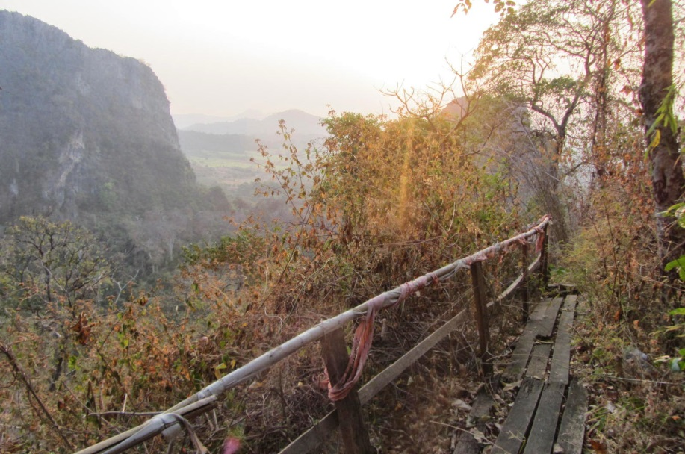
Our visit at Wat Pah Chang Pueng, the Wat of the Fallen Trees (and the nearby cave) and Luang Por Chorb's Cheddi were a bit less hair-raising although the witnessing of a motorcycle accident en route did generate a lot of emotive discussions.
The following day, we attended the Children's Day celebrations at the Summuang School down the road from the Buddha Metta Project. My next unforgettable experience was to unfold at the bamboo grove near the cave a short trek from the Buddha Metta Project. It was here that Ajahn Sudhiro had practised for 8 years. Whilst most of the others chose to remain in the cave, unable to find a comfortable spot, I opted to sit in meditation at a private but open area a short distance from the cave. Halfway through my practice, I opened my eyes in response to a distracting rustling of leaves. I saw a brown snake scuttle across the rocky terrain being chased by a black snake. I thanked my lucky stars as I had nearly chosen that rocky terrain as my 'seat' just moments before. I tried to continue my practice as the black snake retreated to its hiding place. However, it wasn't long before Tan C decided to climb over the top of the cave. The commotion triggered the black snake to resurface as it slid past about ten feet in front of my path. Needless to say, my meditation session had been distrupted beyond return by this point. Nevertheless, Ajahn Sudhiro felt the experience was special enough to recount to the Samayya students on tudong the next day.
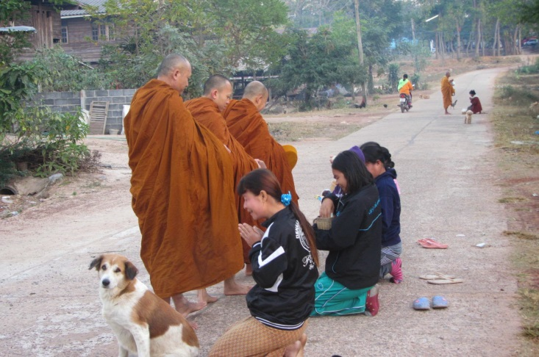
The Cheddi at the Wat of Peacocks (not its real name) offered me the perfect environment for a peaceful meditation session. The abbot reassured us that anyone (even farangs) have the potential to reach nibbana. He also gave us a dhamma talk about relics, letting go, the power of the mind and how to work with bodily pain. We visited the Mae Chee Kaew nunnery before heading for Wat Buddho Thamma Tharo where Luang Por Sompong gave us a dhamma teaching about panna, kilesas (defilements) and finding refuge in oneself.

It only seemed fitting that our journey would take us to the birth place of Ajahn Mun, the monastery where he was ordained as a novice monk and the meeting place of Ajahn Mun with his teacher Ajahn Sao by a water well where Ajahn Mun had made offerings to Ajahn Sao. Ajahn Best and Tan Peter made us feel welcomed at the "Zoo Monastery" where we chanted in memory of a friend who had recently passed away.

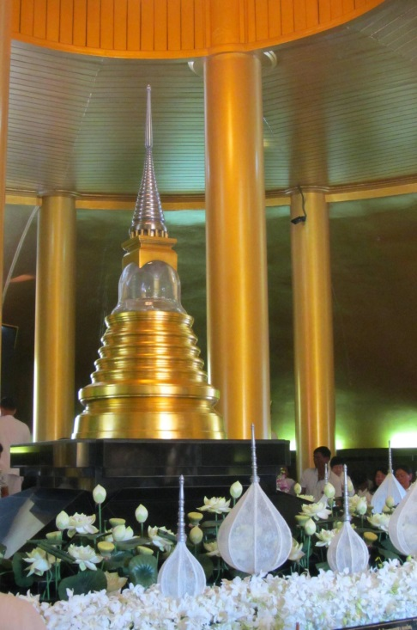
I started off the trip expecting Wat Nong Pah Pong and the Ajahn Chah memorial service to be the highlight of the trip. However, it soon became apparent to me that I was enjoying the journey more than the destination. Nevertheless, I did find Ajahn Chah's Cheddi rather emotionally moving.

For me, the main highlight of the trip was listening to the dhamma talks given by the reknown teachers we met along the way. I had made a determination to be mindful and present throughout the trip. Hence, I listened attentively to every piece of advice they had to impart and diligently wrote them down for future reference. 3 common themes came up repeatedly during the dhamma talks – sati (mindfulness), panna (wisdom) and samadhi (concentration). Whilst these were not new concepts to us, it impressed upon me how simple the Buddha’s teachings are, and yet how powerful it can be if utilised and practised well. I found it very inspiring and it has motivated me to be more diligent with my practice.
Travelling with fellow Kalyana Mittas (spiritual friends) whilst having dhamma discussions was also very enjoyable. This trip has finally given me the opportunity to visit the many famous monasteries I have read and heard about over the years of frequenting its affiliated monasteries in the UK (Harnham Buddhist Monastery in Belsay and Amaravati Buddhist Monastery in Hemel Hempstead).

A few days before leaving Thailand to return to the UK, I commented that I was about to leave for the ‘real life’. A wise man amongst us responded that the humdrum of working life is not the ‘real life’. Living in the dhamma (a term frequently coined by Ajahn Sudhiro) truly is the ‘real life’ - no pretences, no denials or covering things up but instead trying to live life in the present moment, seeing and accepting life the way it is. Having thought about it, I can’t help but agree with him.

